Louisiana Crab Task Force Meeting
Britney Breaux, Chair
Tuesday, September 26, 2023, 1:00pm
Terrebonne Parish Library
151 Library Drive, Houma, LA
I. Pledge of allegiance
II. Roll call and introduction of guests
Voting Members Present:
Eric Blanchard
Laquita Meek
Sheb Callahan
Joey Edgar
George Jackson
Edward Frekey
Britney Breaux

Voting Members Absent:
Chalin Delaune
Trudy Luke
Pete Gerica
Al Cassagne
Rodney Parfait
Dannon Lacoste

Non-Voting Members Present:
Peyton Cagle
Julie Falgout in for Melissa Daigle

Non-Voting Members Absent:
Jack Isaacs
Edward Skena

No quorum, board did not take up the January 17th meeting minutes or approval of the agenda. Skipped to New Business.

VI. New Business

- Jason Froeba provided an update on fisheries disaster funding

2019 flood Disaster Spending Plan, state-wide meetings to provide information
- In 2019, extensive freshwater flooding caused significant impacts to coastal resources including oysters, shrimp, blue crabs, and finfish
- During the 2019-2020 fiscal year, Congress appropriated a total of $165 million for declared fisheries disasters in the United States
- National Oceanic and Atmospheric Administration (NOAA) allocated $58,284,841 of this funding to Louisiana

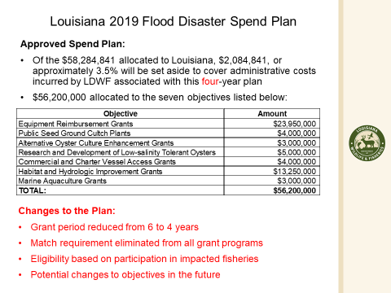
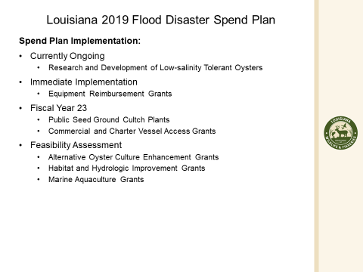
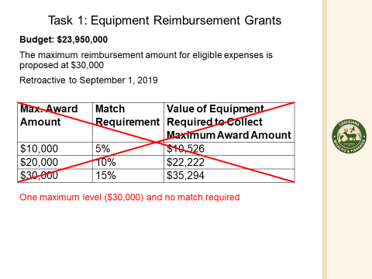
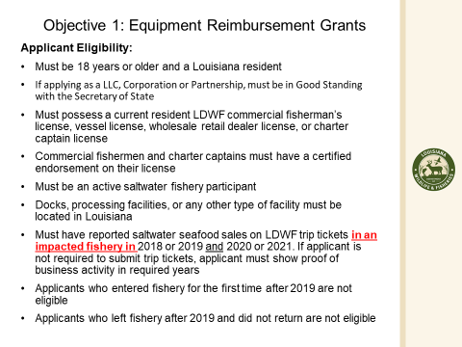
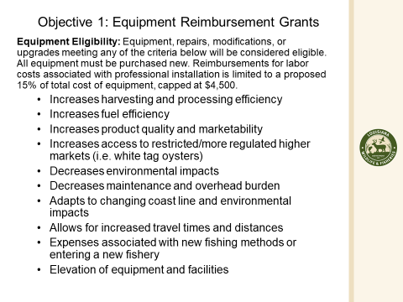
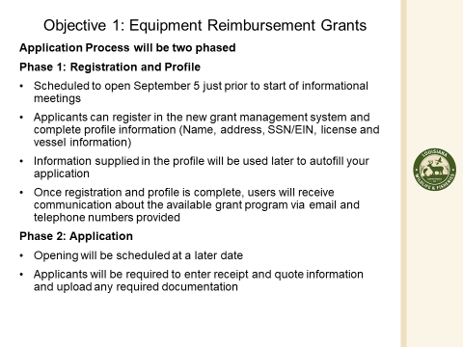
Sheb Callahan, Joey Edgar and George Jackson arrived, the board called roll again at this point and quorum was achieved.

Voting Members Present:
Eric Blanchard
Laquita Meek
Sheb Callahan
Joey Edgar
George Jackson
Edward Frekey
Britney Breaux

Voting Members Absent:
Chalin Delaune
Trudy Luke
Pete Gerica
Al Cassagne
Rodney Parfait
Dannon Lacoste

Non-Voting Members Present:
Peyton Cagle
Julie Falgout in for Melissa Daigle

Non-Voting Members Absent:
Jack Isaacs
Edward Skena

III. Eric Blanchard motioned to approve the January 17, 2023 meeting minutes, 2nd by George Jackson. Motion carries.
IV. Edward Frekey motioned to remove item D. under new business, “To Hear a Presentation on an Oyster Shell Recycling Program in Terrebonne Parish That Would Use Derelict Crab Traps from 2024 Removal Program- CRCL, Darrah Bach” and approve the agenda as amended, 2nd by Eric Blanchard. Motion carries.
V. Financial report:
Remaining Fund Balance- $46,066
Remaining Budget Balance- $46,066

Edward Frekey motioned to approve the financial report as presented, 2nd by Eric Blanchard. Motion carries.
VI. New Business
- Peyton Cagle provided a presentation on the 2024 derelict crab trap removal areas
- The first closure will occur in the Pontchartrain Basin, between southern Lake Borgne and the eastern portion of the Biloxi Marsh, from 12 a.m. February 1, 2024, through 11:59 p.m. February 14, 2024.
- The second closure will occur in the Barataria Basin, south of Empire and Venice, from 12 a.m. February 1, 2024, through 11:59 p.m. February 14, 2023.
- The third closure will occur in the Terrebonne Basin, between the Houma Navigational Canal and Bayou du Large, from 12 a.m. February 1, 2024, through 11:59 p.m. February 14, 2024.
- The fourth closure will occur in the Vermilion-Teche Basin, in an area from the Acadiana Navigational Channel and the western shore of Vermilion Bay, from 12 a.m. February 1, 2024, through 11:59 p.m. February 14, 2024.
- The fifth closure will occur in the Mermentau Basin, in the Mermentau River south of Catfish Locks, from 12 a.m. February 1, 2024, through 11:59 p.m. February 14, 2024.
- The sixth closure will occur in the Pontchartrain Basin, in Lake Maurepas, from 12 a.m. February 26, 2024, through 11:59 p.m. March 6, 2024.
Eric Blanchard requested that they label landmarks when making big vertical or horizontal runs across open marsh. This is typically done, but in this one instance will try to label a mile marker or something where the horizontal run starts

- The board heard the MSC crab reassessment results

Peyton Cagle provided the results of the MSC crab reassessment to the board. Explained that the current reassessment has two conditions on the fishery. Both of these conditions pertain to diamond back terrapins (DBT), the lack of population research and if incidental mortality from crab traps hinder the population. Explained that an action plan is needed to submit with any comments we have regarding the scoring. Recommended that the task force utilize ongoing research by Dr. Tim Clay as part of the action plan and it could be considered by the LCTF if they wanted to study, recommend, or support research on observer coverage, excluder devices, or a bycatch study.

Dr. Clay spoke of his research and the upcoming head-start program where they will utilize local schools to help raise hatched diamond back terrapins and release them; similar work has been done on the east coast. The LCTF spoke heavily on concerns of additional regulations and their concerns that new data could negatively impact them. MSC does not determine state regulations, this is simply an action plan to show the fishery client (LCTF) is working to address the conditions.

Eric Blanchard motioned to support Dr. Clay’s hatchery research as a part of an action plan for MSC, 2nd by Laquita Meek. Motion carries.

Sheb Callahan exited the meeting and the task force lost quorum.

- Officer elections – no action taken, lost quorum

VII. Public comment- no comment
VIII. Next meeting to be announced at a later date, meeting later set for Tuesday, February 20, 2024 for 10:00am at the Terrebonne Parish Council Chambers.

